 COSC 3380
Name: __________________ Seat #___

Project 1:
(100 points)
(Due date found in the COSC 3380 BB Calendar!)

1.a 0 points
1.b 30 points
1.c 10 points
1.d 10 points
2. 20 points
3. 30 points

PLEASE ENTER YOUR GRADE IN THIS BOX & ALSO on the CHECK SHEET:

1. (50 points)
a. (0 points – separate document) Using the above COSC3380 Data Requirements create the ERD Model (must fit on one page)
(Conceptual Model – What - Analysis).
E1: Product – A1: ProductID
E2: ProductLine – A1: ProductLineID
E2: ProductLine – A2: ProductLineName

E1: Product – A2: ProductName
E2: ProductLine
E1: Product – A3: ProductFinish
E1: Product
E1: Product – A4: ProductStandardPrice
R1: Includes
E3: Order
E3: Order – A1: OrderID
E3: Order – A2: OrderDate
E4: Customer
E4: Customer – A1: CustomerID
E4: Customer – A2: CustomerName
E4: Customer – A3: CustomerAddress
E4: Customer – A4: CustomerCity
E4: Customer – A6: CustomerPsotalCode
E4: Customer – A8: CustomerUsername
E4: Customer – A9: CustomerPassword
R2: Submit
E5: OrderLine – A1: OrderedQuantity
E5: SalesTerritory
E5: SalesTerritory – A1: TerritoryID
E5: SalesTerritory – A2: TerritoryName
R5: Serves
E6: SalesPerson
E6: SalesPerson – A1: SalesPesrosnID
E6: SalesPerson – A2: SalesPesrosnName
E6: SalesPerson – A3: Telephone
E6: SalesPerson – A4: SalesPesrosnEmail
E6: SalesPerson – A5: SalesPesrosnUsername
E6: SalesPerson – A6: SalesPesrosnPassword
E1: Product – A5: ProductPhoto
R3: OrderLine
R4: DoesBusiness
E1: Product – A1: UpdatedStandardPrice
E7: PriceUpdates
E4: Customer – A7: CustomerEmail
E4: Customer – A5: CustomerState
E1: Product – A2: PriceUpdateDate

b. (30 points) COSC3380 Relational Model (must fit on one page)
(Internal Model – How - Design).
#Relations/Tables: _5__

CustomerID | CutomerName | CustomerAddress | CustomerCity | CustomerState | CustomerPostalCode
CustomerEmail | CutomerUsername | CustomerPassword
Customer
Order
OrderID | OrderDate | CustomerID

OrderLine
ProductID | OrderID | OrderedQuantity

Product
ProductID | ProductName | ProductFinish | ProductstandardPrice | ProductPhoto | ProductLineID

ProductLine
ProductLineID | ProductLineName

SalesPerson
SalesPersonID | SalesPersonName | SalesPersonTelephone | SalesPersonEmail | SalesPersonUsername
SalesPersonPassword | SalesTerritoryID

SalesTerritory
SalesTerritoryID | SalesTerritoyName

DoesBusinessIn
CustomerID | SalesTerritoryID

PriceUpdates
UpdatedStandardPrice | PriceUpdateDate | ProductID

E2: ProductLine – A1: ProductLineID
E2: ProductLine – A2: ProductLineName
E1: Product – A1: ProductID
E1: Product – A2: ProductName
E2: ProductLine
ProductLine
E1: Product – A3: ProductFinish
E1: Product
E1: Product – A4: ProductStandardPrice
R1: Includes
E3: Order
E3: Order – A1: OrderID
E3: Order – A2: OrderDate
E4: Customer
E4: Customer – A8: CustomerUsername
E4: Customer – A9: CustomerPassword
R2: Submit
E5: SalesTerritory
E5: SalesTerritory – A1: TerritoryID
E5: SalesTerritory – A2: TerritoryName
R5: Serves
E6: SalesPerson
E6: SalesPerson – A1: SalesPesrosnID
E6: SalesPerson – A2: SalesPesrosnName
E6: SalesPerson – A3: Telephone
E6: SalesPerson – A4: SalesPesrosnEmail
E6: SalesPerson – A5: SalesPesrosnUsername
E6: SalesPerson – A6: SalesPesrosnPassword
Product
E1: Product – A5: ProductPhoto
R3: OrderLine
E7: PiceUpdates – A1: UpdatedStandardPrice
OrderLine
E7: PriceUpdates
E5: OrderLine – A1: OrderedQuantity
E7: PiceUpdates – A1: UpdatedDate
PriceUpdates
Order

E4: Customer – A1: CustomerID

E4: Customer – A2: CustomerName

E4: Customer – A3: CustomerAddress

E4: Customer – A4: CustomerCity

E4: Customer – A6: CustomerPsotalCode

E4: Customer – A5: CustomerState

DoesBusinessIn
E4: Customer – A7: CustomerEmail
R4: DoesBusiness
SalesTerritory

Customer

SalesPerson

c. (10 points) Given the unnormalized data in b. convert Relations to 1NF, 2NF, and 3NF.
(If already in 3NF, just state so and do not copy the Relations from b.)

Already in 3NF

d. (10 points) Draw the revised ERD Model that corresponds to the 3NF Relations for c.
(You HAVE to use ER symbols from the textbook!)
(If no change to the ERD, just state so and do not copy the ERD from a.)

No Need for a revised ERD

2. (20 points)
Using SQL*Plus (Oracle DBMS) create the 3NF Tables from complete Project1 specified in 1. Display the structure for each Table after you created it. Make sure you implement all the necessary integrity constraints. SQL comment the SQL code. Turn in screenshots of each SQL command (SQL COMMENTS ARE A MUST) and its output as Project1.doc. SQL code needs to also be submitted to BB as Project1.sql.
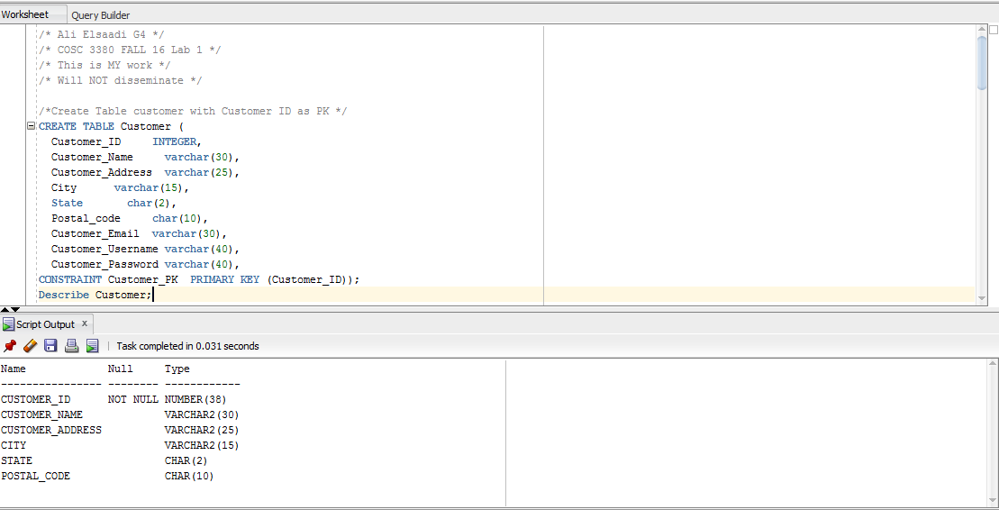

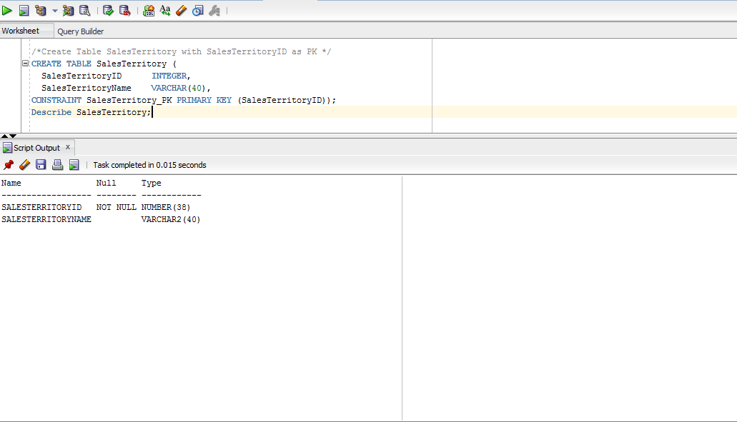

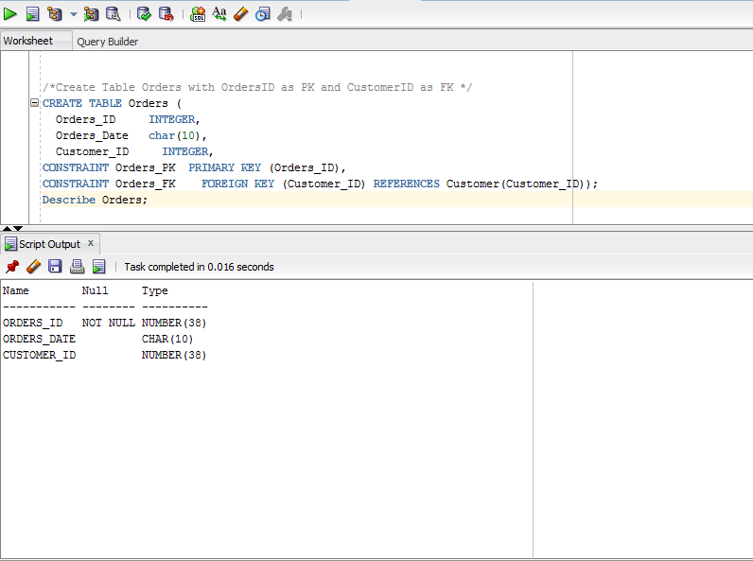

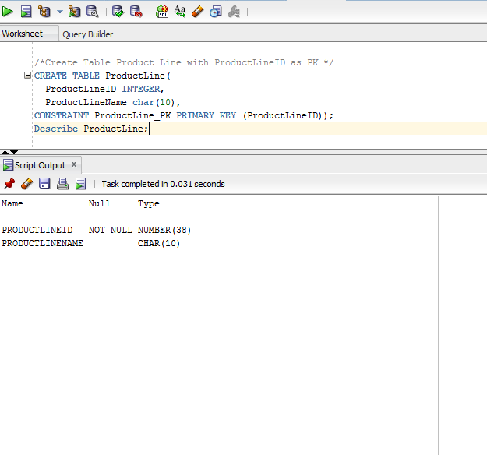

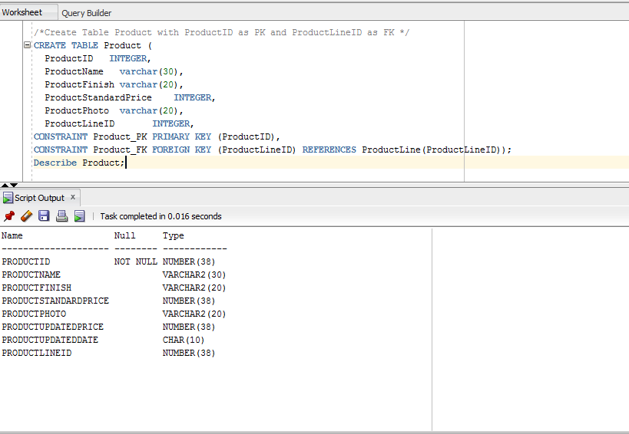

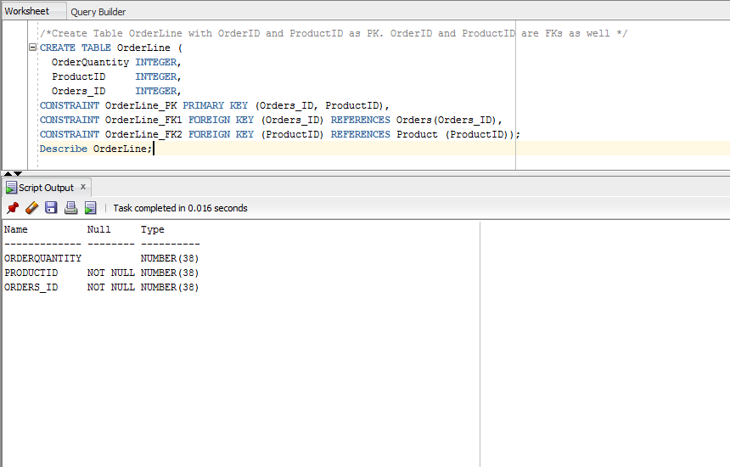

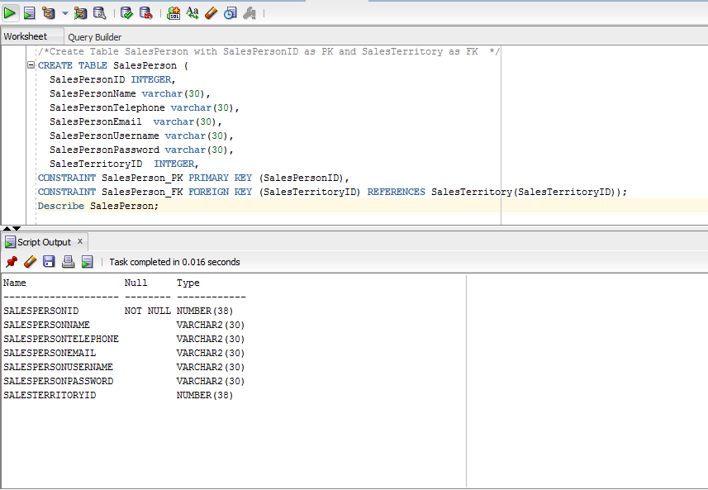

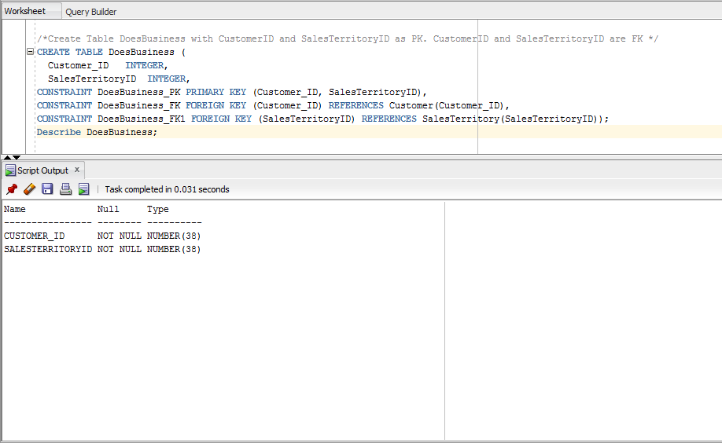

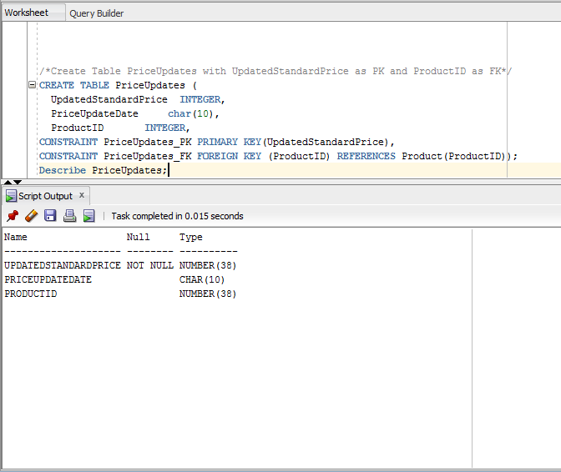

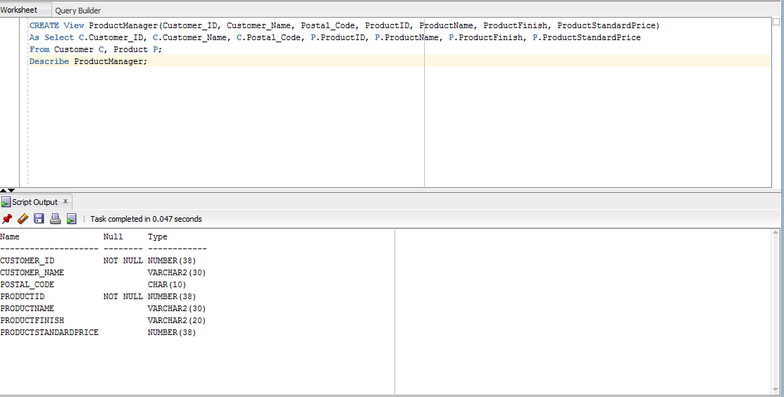

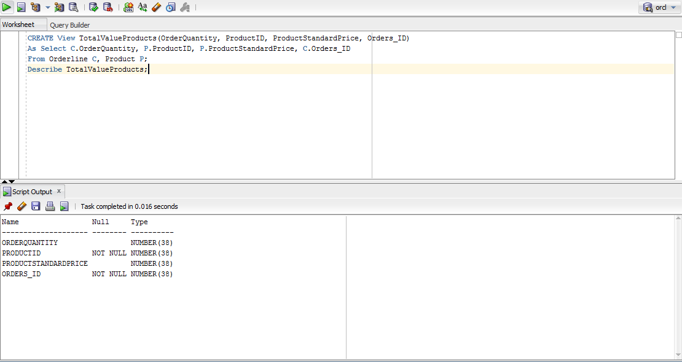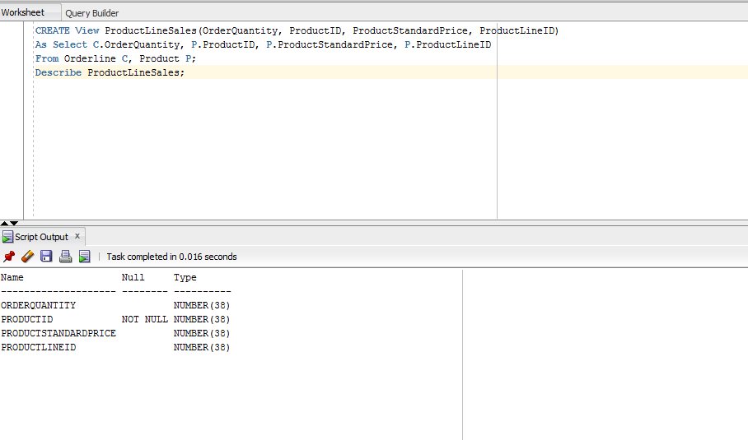

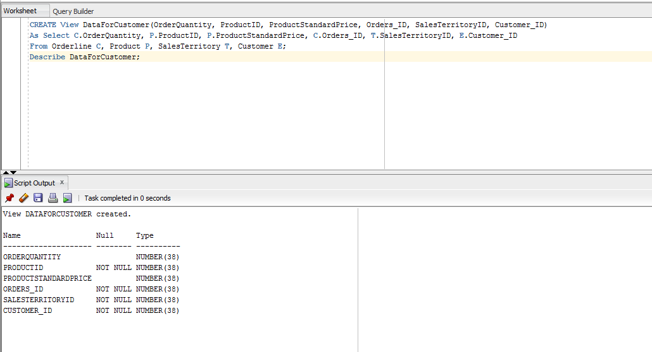

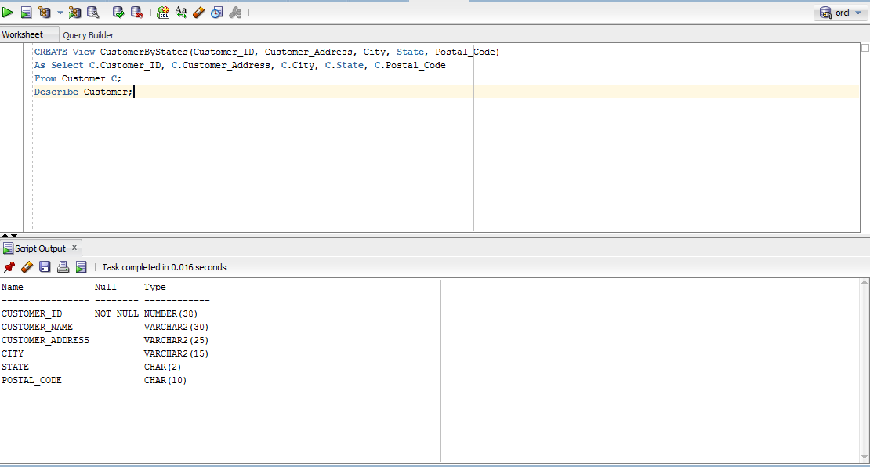

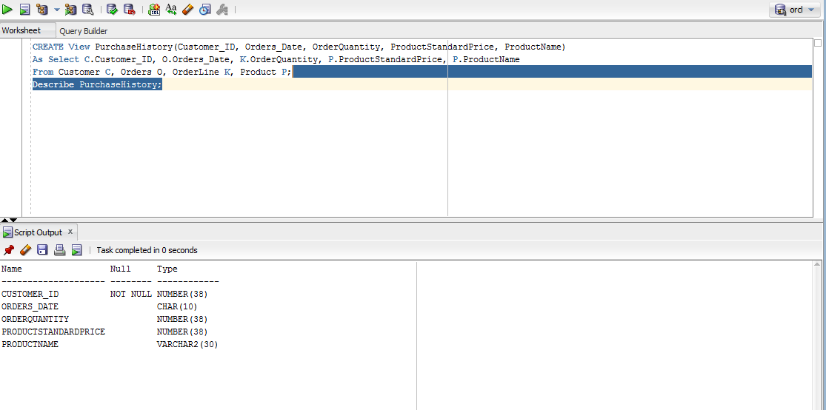

3. (30 points)
Create the COSC3380 Database tables in Microsoft Access DBMS (as Project1ACCESS) or Microsoft SQL Server 2008 DBMS (as Project1MSSQL) (available in the Computer Science LABS). Then request the Table Relationships Diagram for the Database. This will show you a visual representation of the COSC3380 Database. Turn in a screenshot of it. SQL code needs to also be submitted to BB as Project1ACCESS.sql or Project1MSSQL.sql.

